**SALESFORCE CRM PROJECT**

**PROJECT NAME : TO SUPPLY LEFTOVER FOOD TO POOR**

**PROJECT OVERVIEW :**

This project aims to streamline the process of leftover food distribution using salesforce.

* **Goal:** Efficiently distribute leftover food to reduce food waste and address hunger.
* **Impact:** Reduce food waste, address hunger, and improve the management of food distribution points, tasks and volunteers.
* **Technology:** Salesforce tools manage records, workflows, and data visualization, ensuring seamless operations.

**OBJECTIVE :**

The project defines measurable goals for societal and operational improvement .

Business Goals :

* + Address societal issues like food waste and hunger.
  + Enhance operations, transparency, and accountability

Deliverables include:

* Custom objects: Drop-off point, Task, Volunteer, and Execution Detail.
* Reports and dashboards for operational insights.
* Automated workflows for efficiency .

**PHASE – 1 : Requirement Analysis & Planning**

PROBLEM STATEMENT : According to the recent statistics on an average daily almost 1 million people go to bed hungry and daily more that 1 ton of food is being wasted so to reduce the food wastage and to help those people we built a app that is the Food Connect .

SOLUTION : The “Food Connect” App will help many people with a simple contribution in this we have solution for different things .

* Firstly it can gather volunteers from across the country who are willing to help it helps to serve people all around the country .
* Next it also has a feature where people can send information about any left over food that they are willing to donate to others .
* After that the near by volunteer is sent an information of the location of the food he/she goes and picks the food .
* Then he/she goes to the nearest location and distribute the food .

OBJECTIVE :

The main goals and objectives of this project are :

* To address issues life food wastage and hunger .
* To ensure that all humans get basic need like food .
* To create awareness among everyone .

**PHASE – 2 : Salesforce Development – Backend & Configurations**

STEP – 1 : Initially we go to the “ https://developer.salesforce.com/signup “ and create a sales force developer account . This will help us build the whole project after the successful creation of the account we will get the home page .

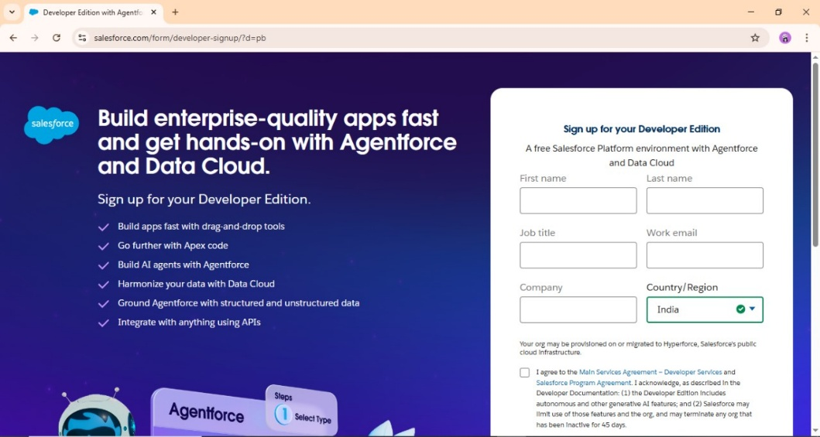

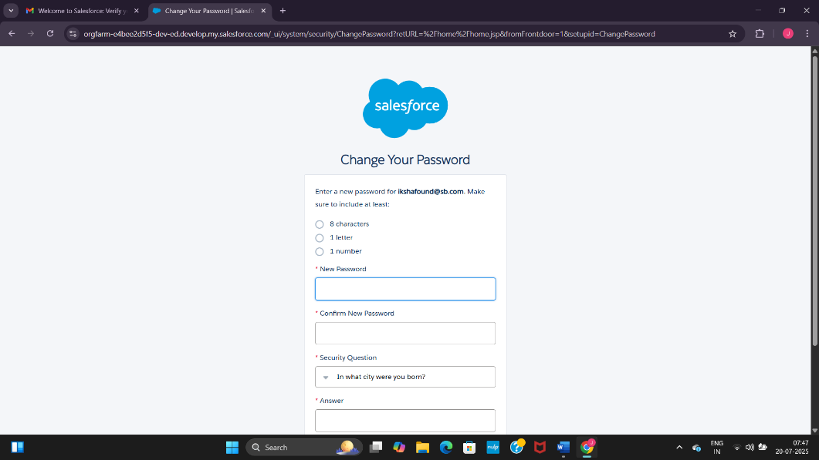

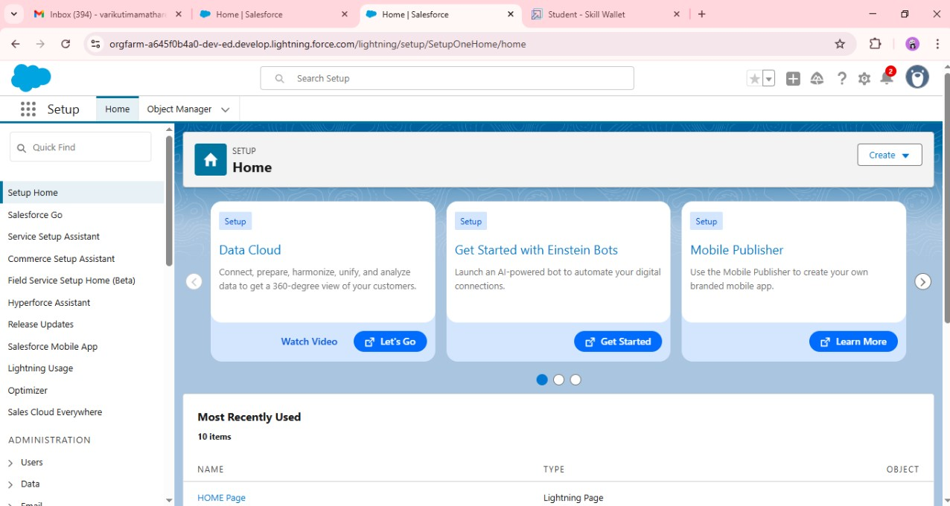

STEP – 2 : In the second step we create the objects and add the necessary fields to the related object we have different fields for donation , volunteers , execution and many more .

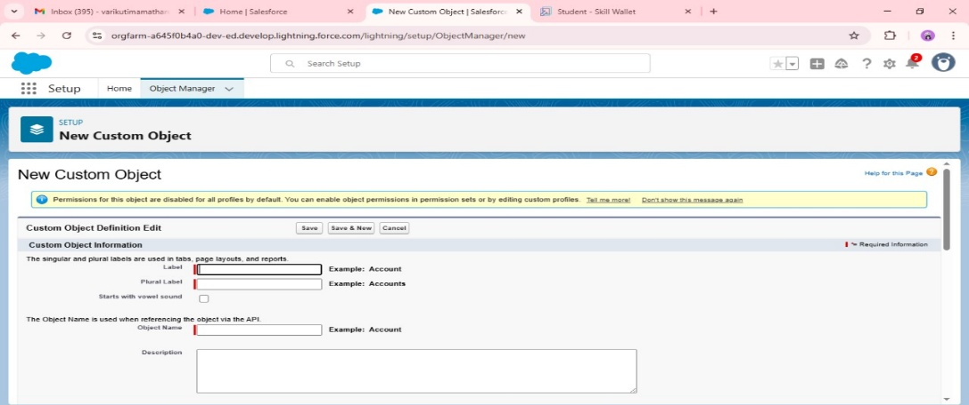

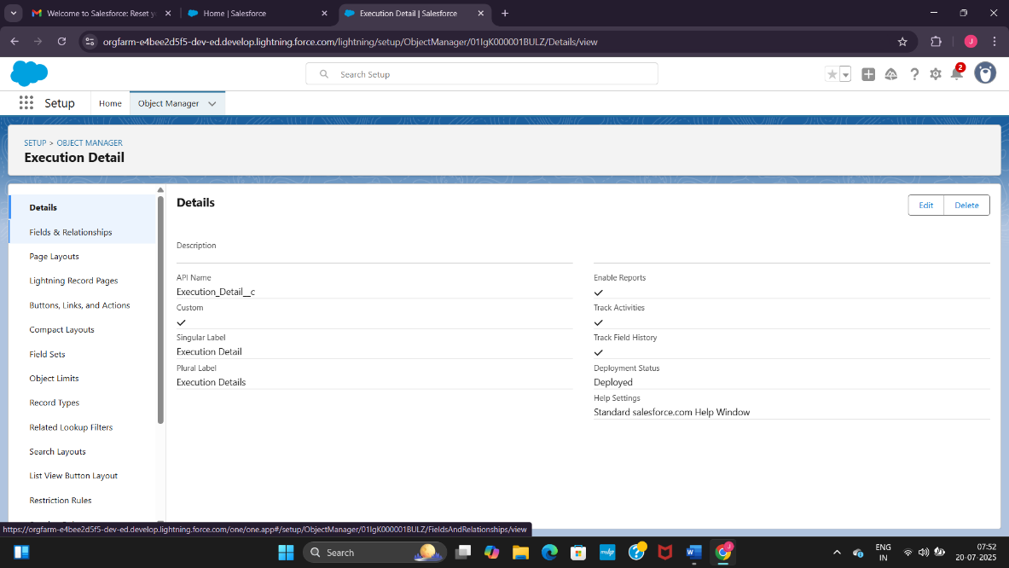

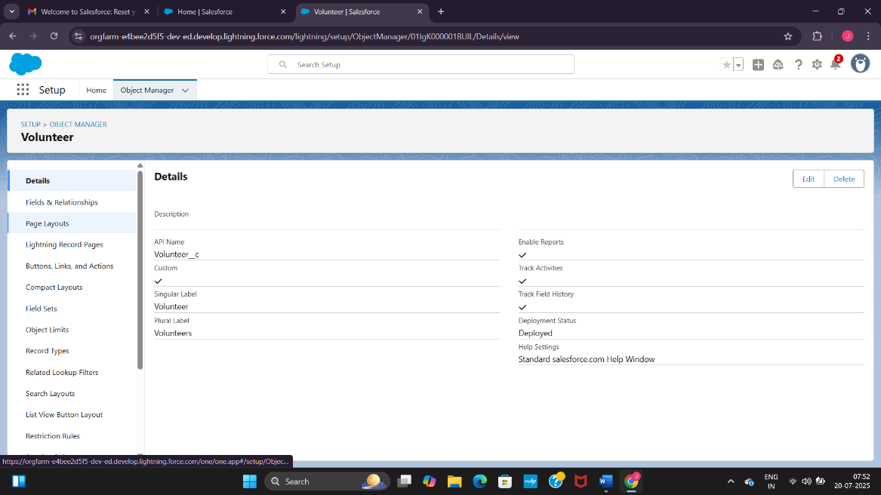

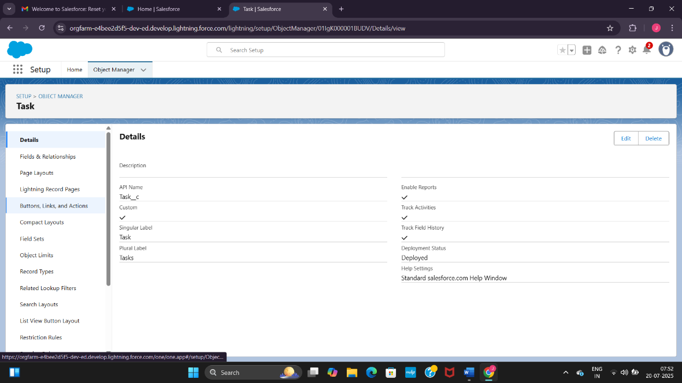

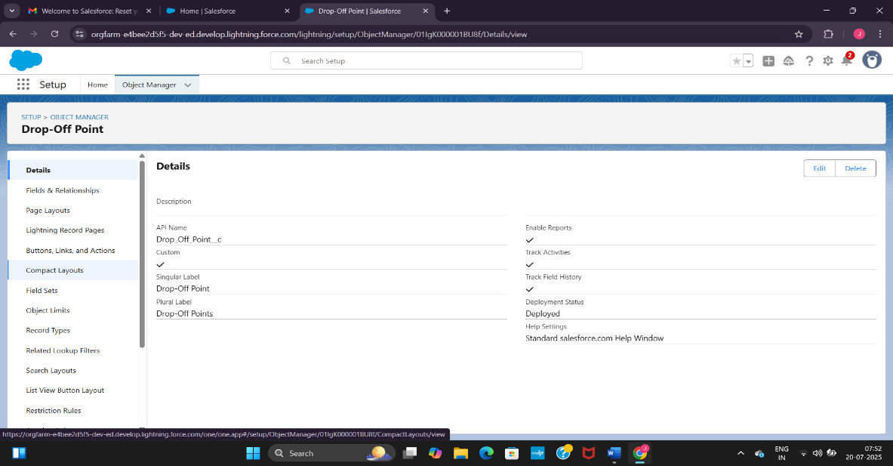

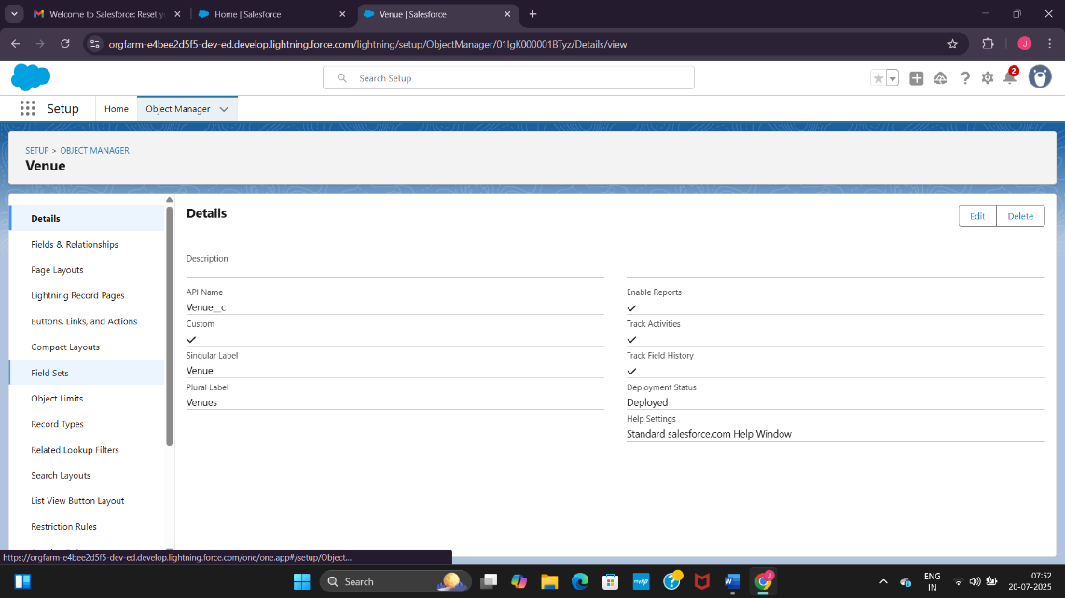

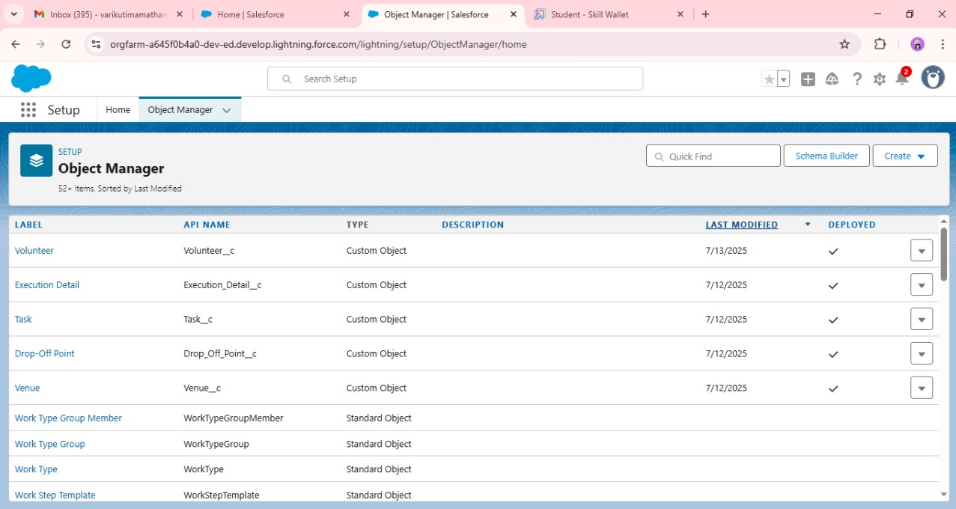

STEP – 3 : In this step we create a flow with the name venue form that flow consists of all the details that should be present in the form which includes the volunteer details the donation details and execution details . Along with that we have also the details of the drop off point .

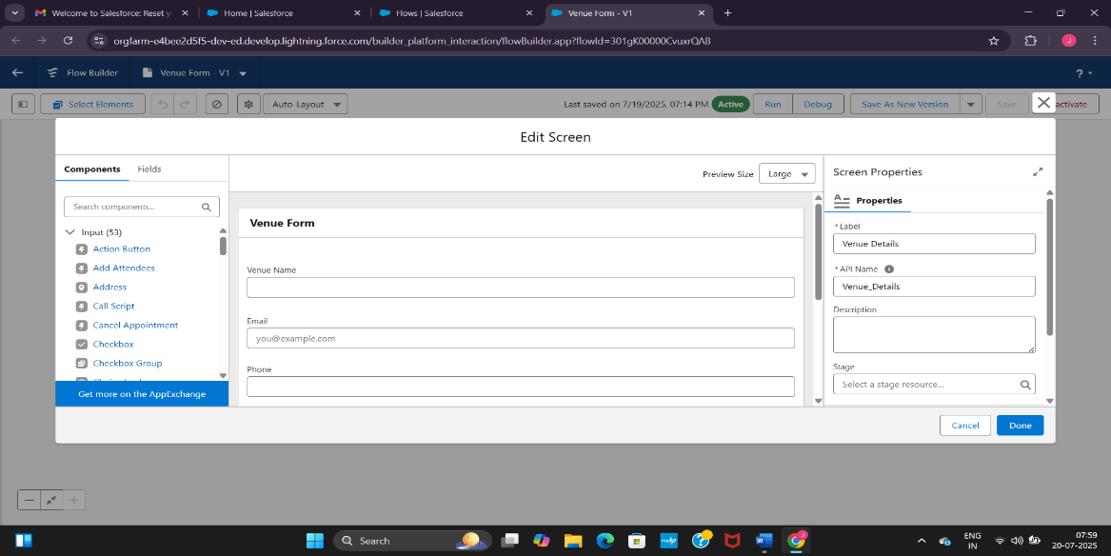

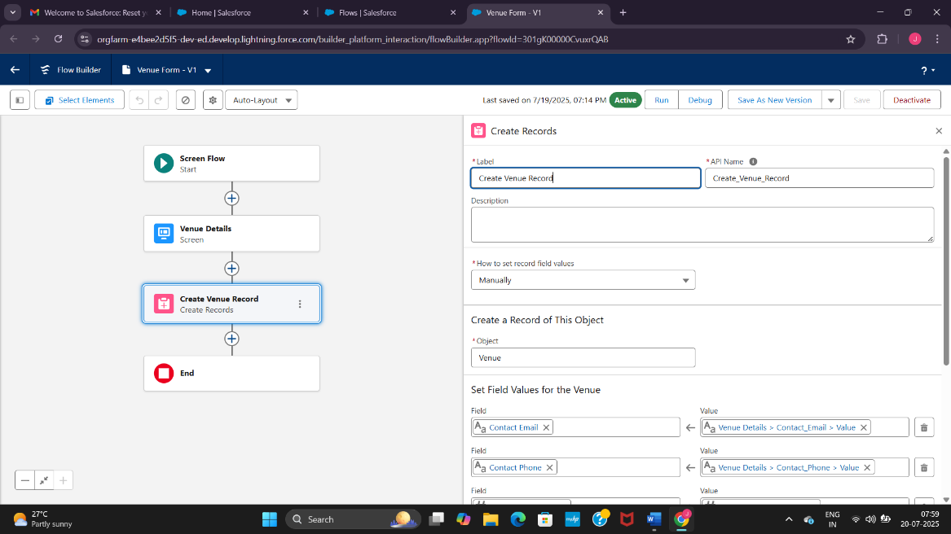

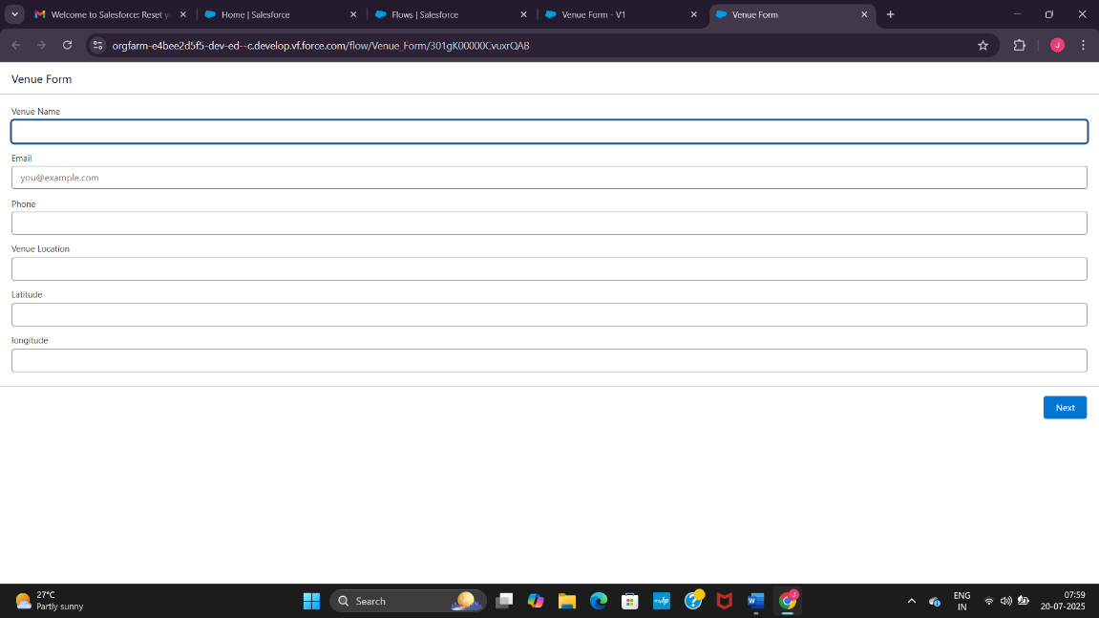

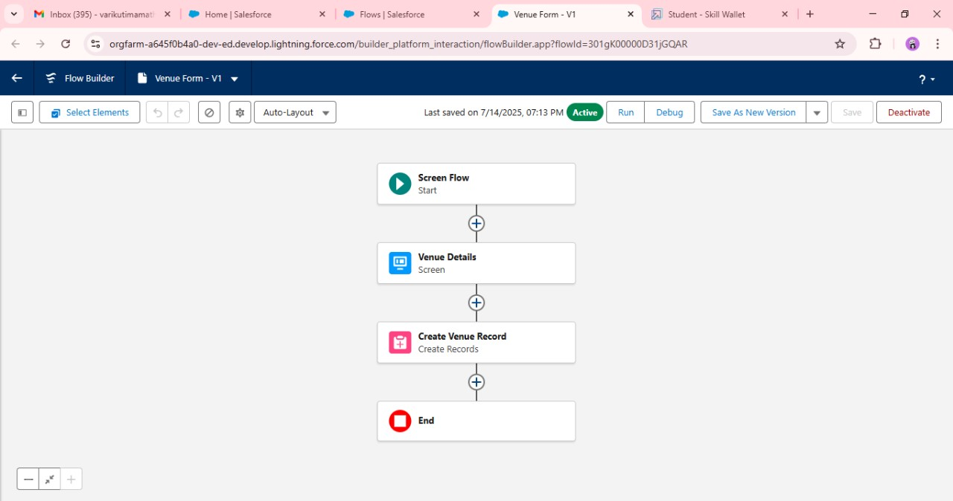

Step – 4 : In this step we create a trigger which helps in the drop off point work .

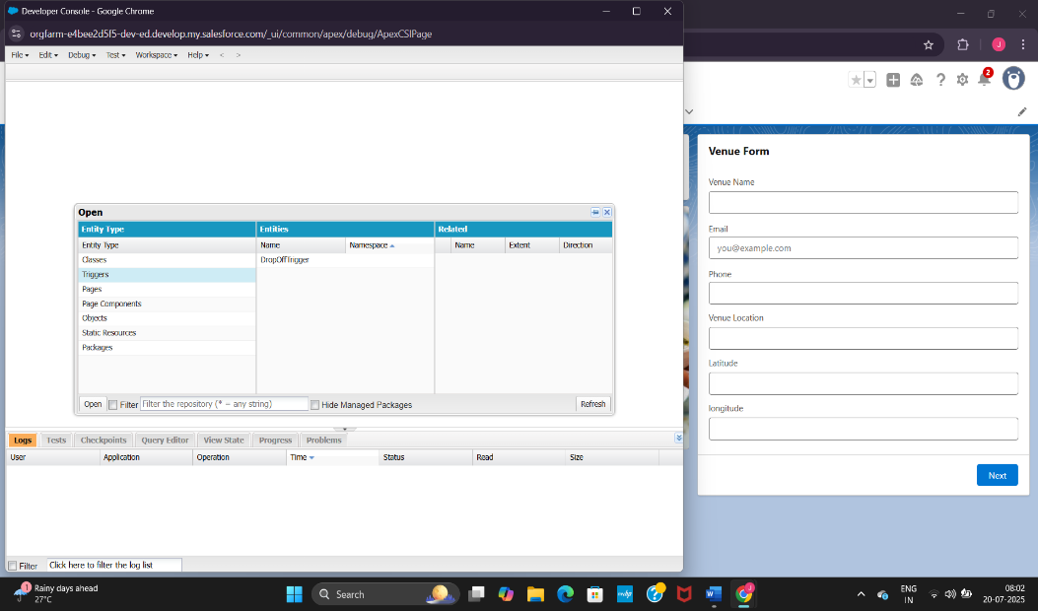

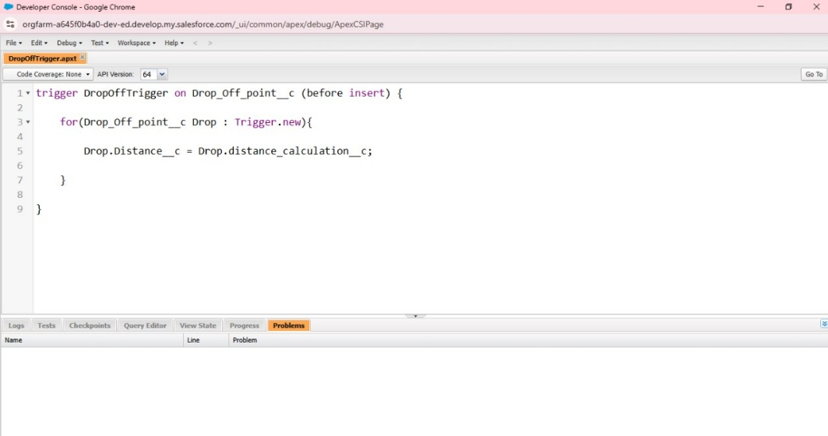

**PHASE – 3 : UI / UX Development & Customization :**

STEP – 1 : In this we create a lightning app builder which helps us to create or build the over all structure of the app that help us in the further process .

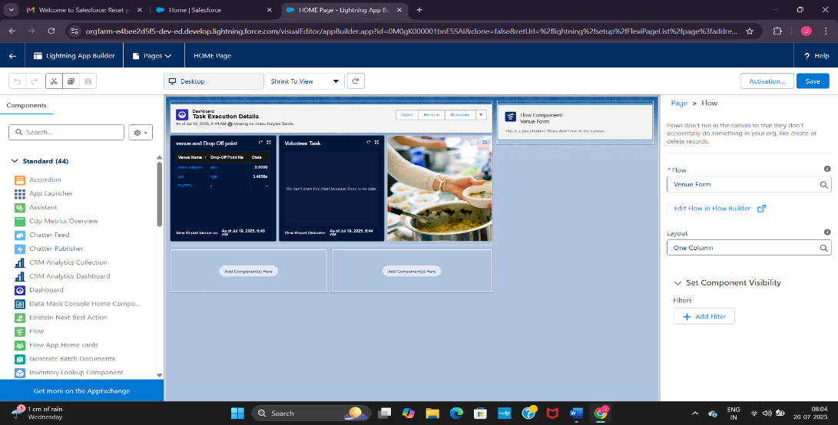

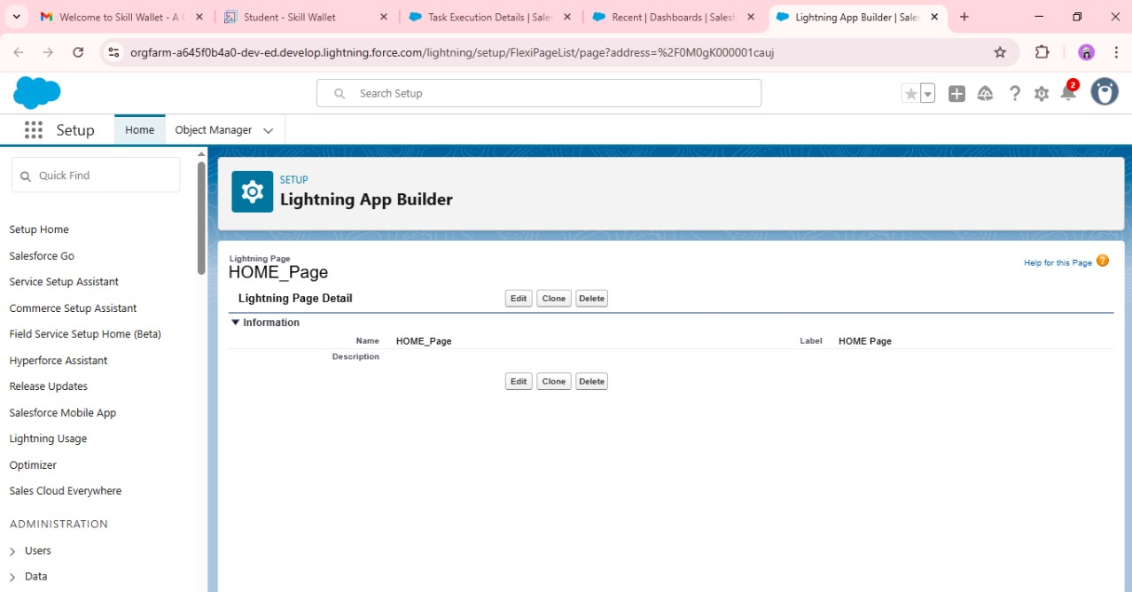

STEP – 2 : In this we create the reports these reports help us to include all the details and all the fields that are needed to be included in the app .

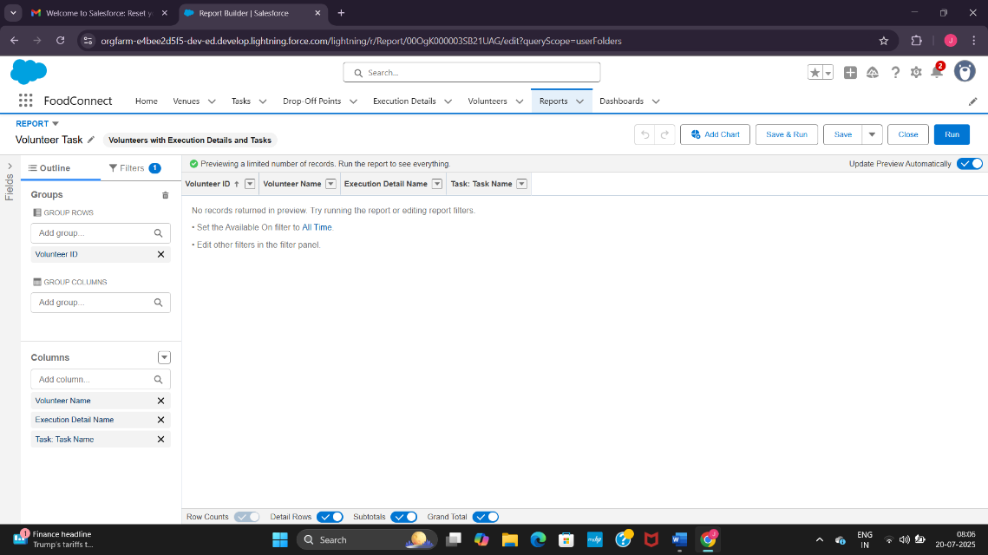

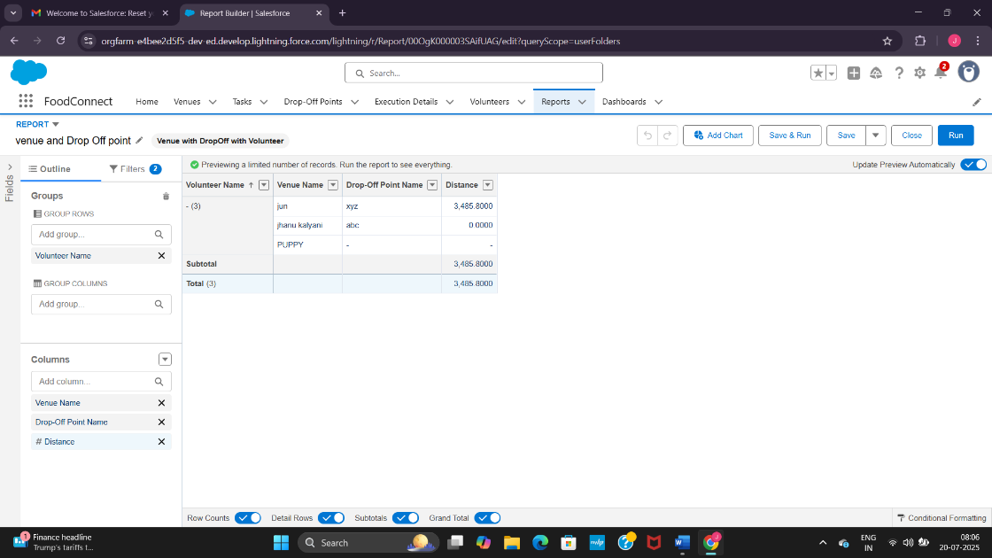

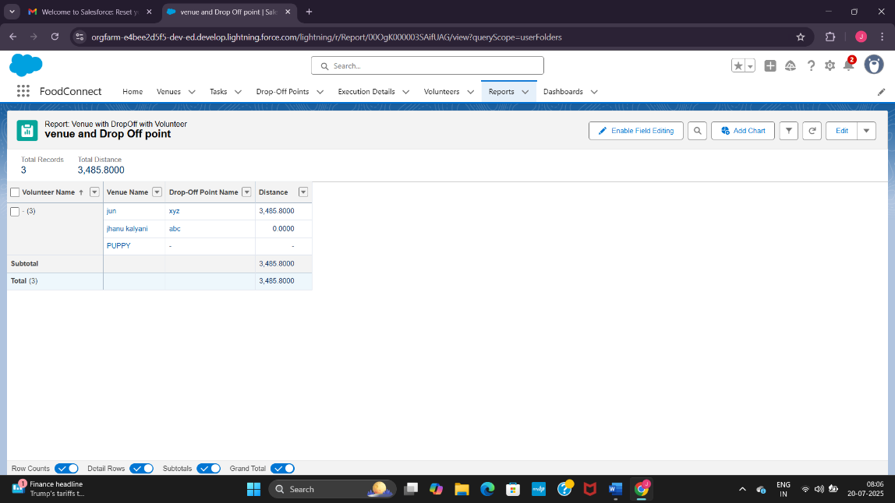

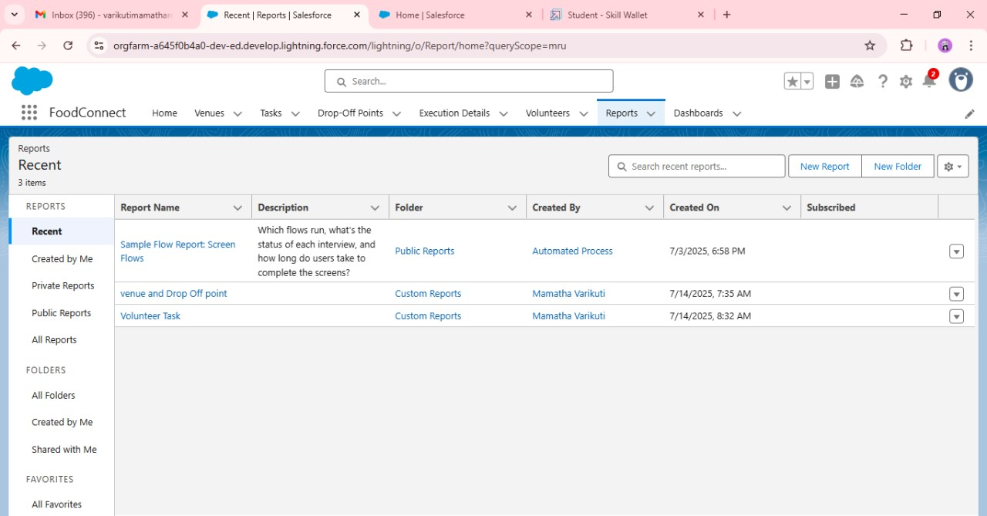

STEP – 3 : In this step we create two different dashboards the first one is the organizational details dashboard where we include the reports .

The second dashboard is the task-executional dashboard which acts also as the home page of the app . These two dashboards one is a custom dashboard that is which acts as the home page and the next is the private dashboard that display the details .

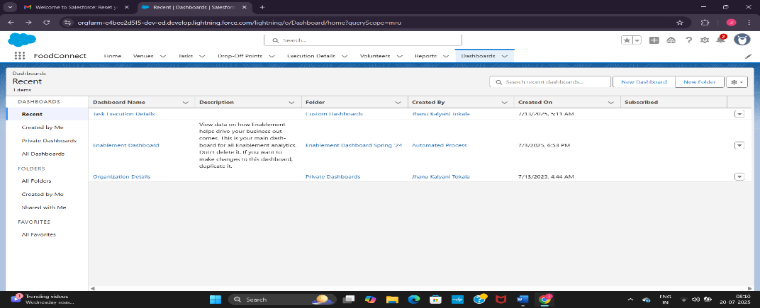

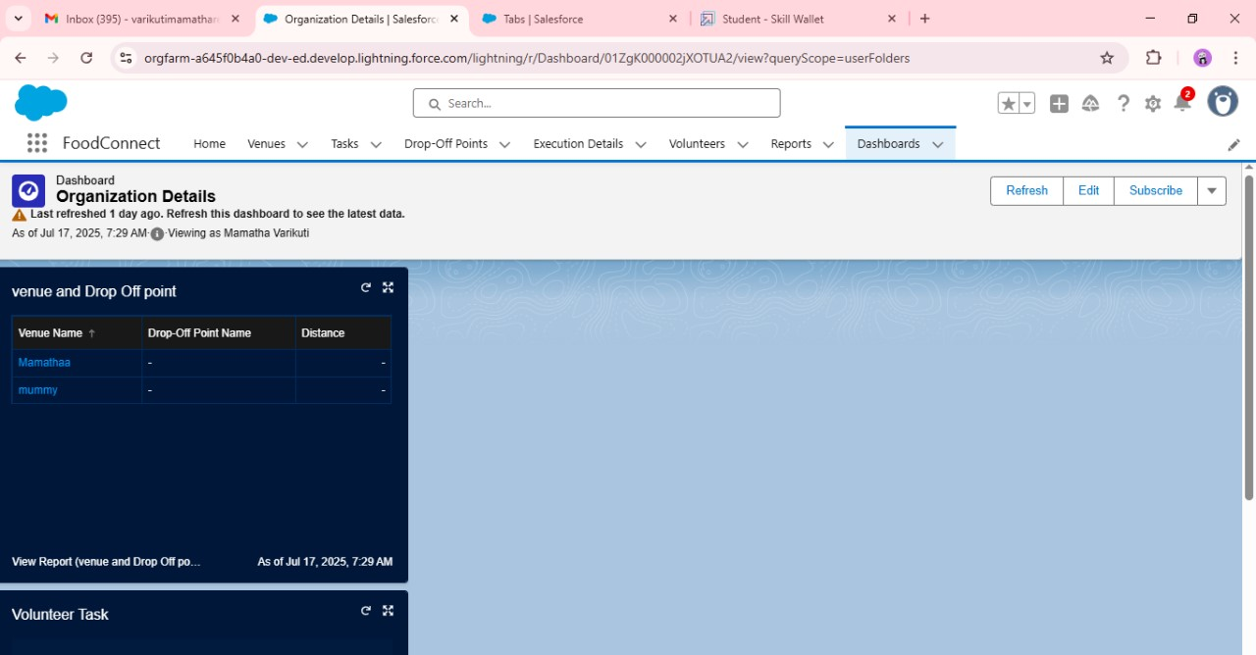

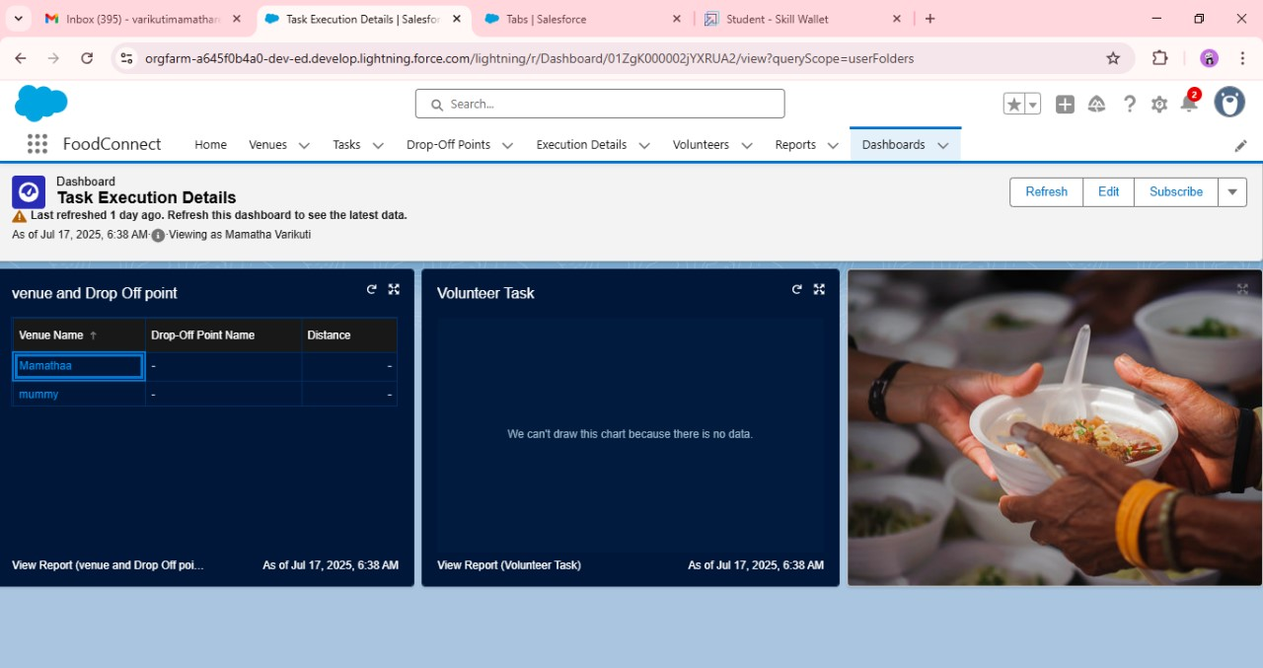

**PHASE – 4 : Data Migration , Testing & Security :**

All the setup and creation of the App has been completed now we have to add the data into the app and then do the testing and give security .

Firstly we add the data into the page it takes the details in the venue form page and we fill those details .

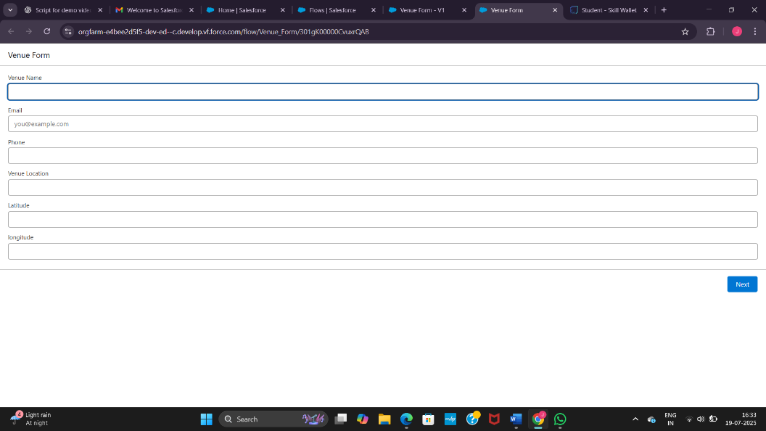

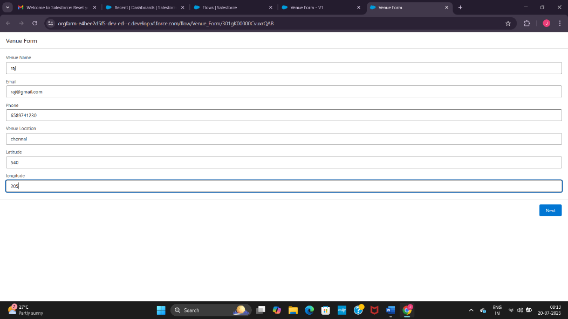

After including the details just check if it showing any error or are there any inappropriate values entered into the fields.

At the last now to maintain the security and avoid any problems in the work flow of the apps we include the rules and settings in a particular way to ensure that all the details and records are safe in the app.

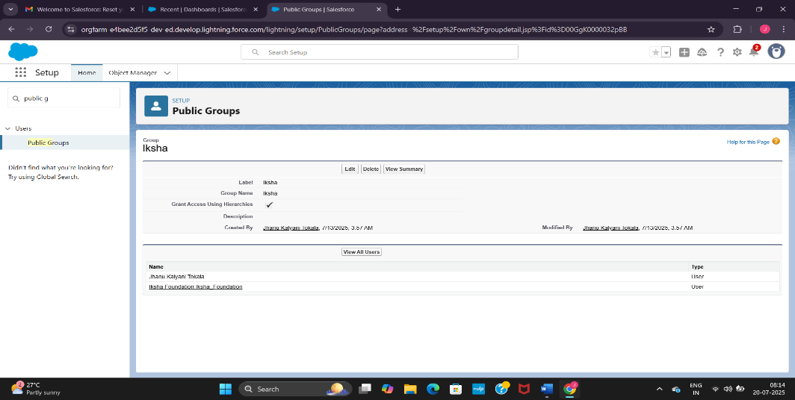

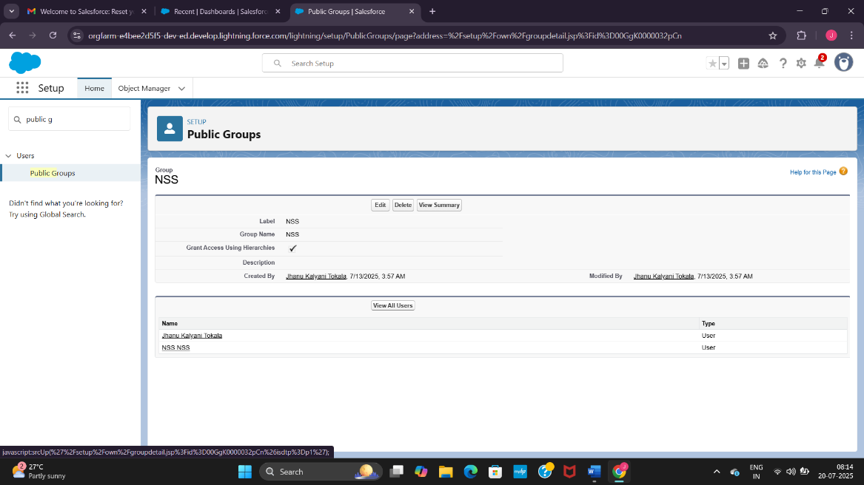

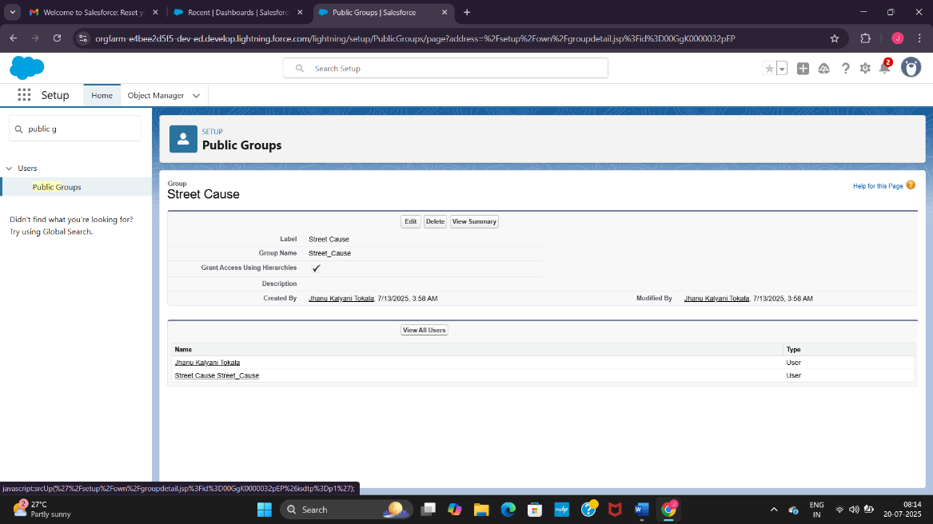

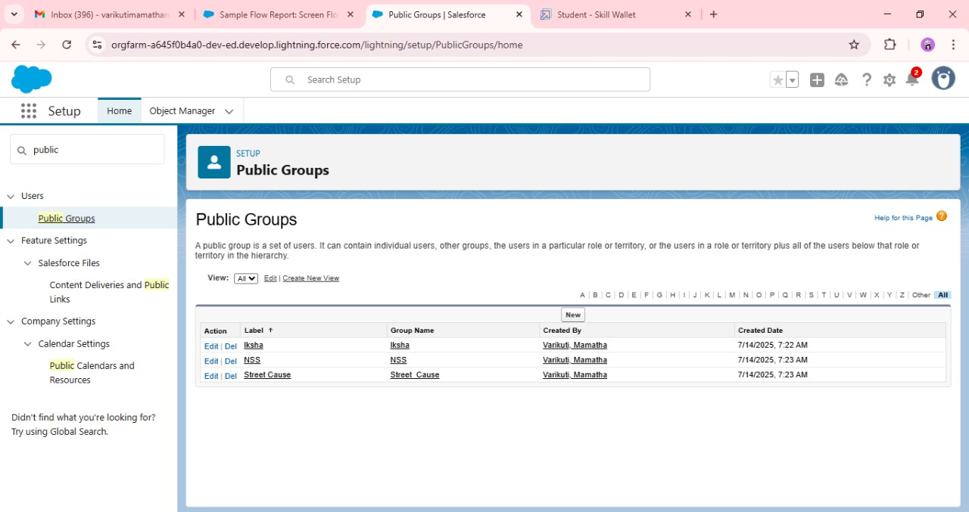

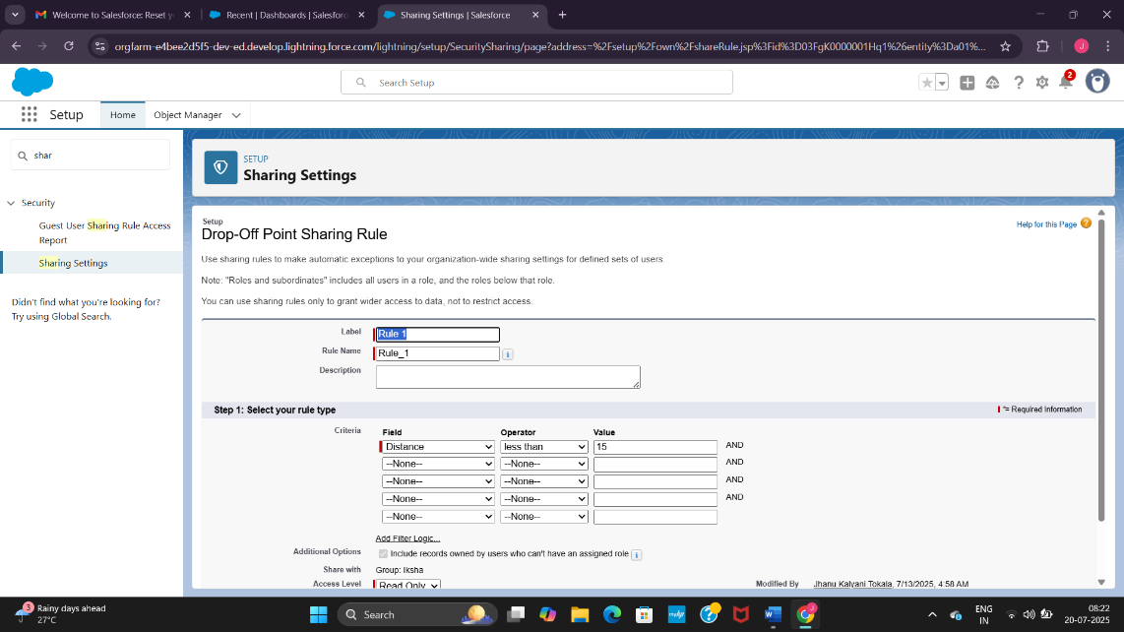

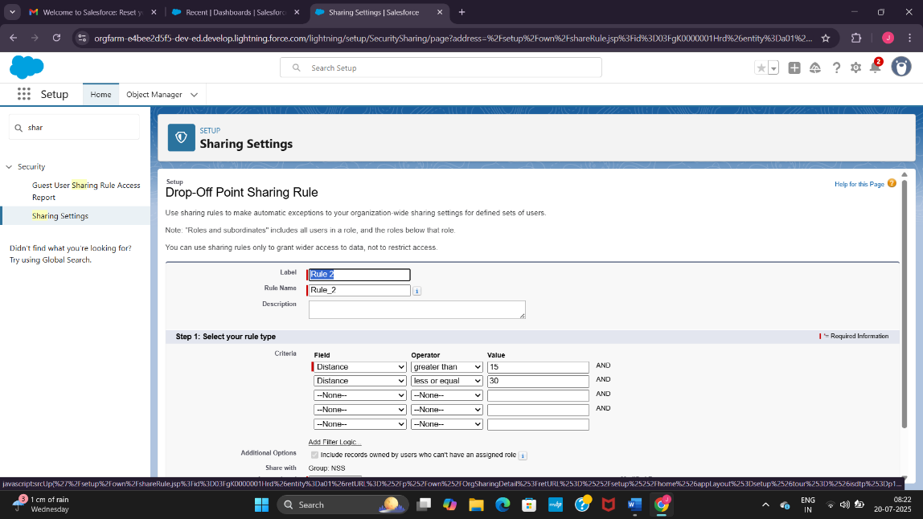

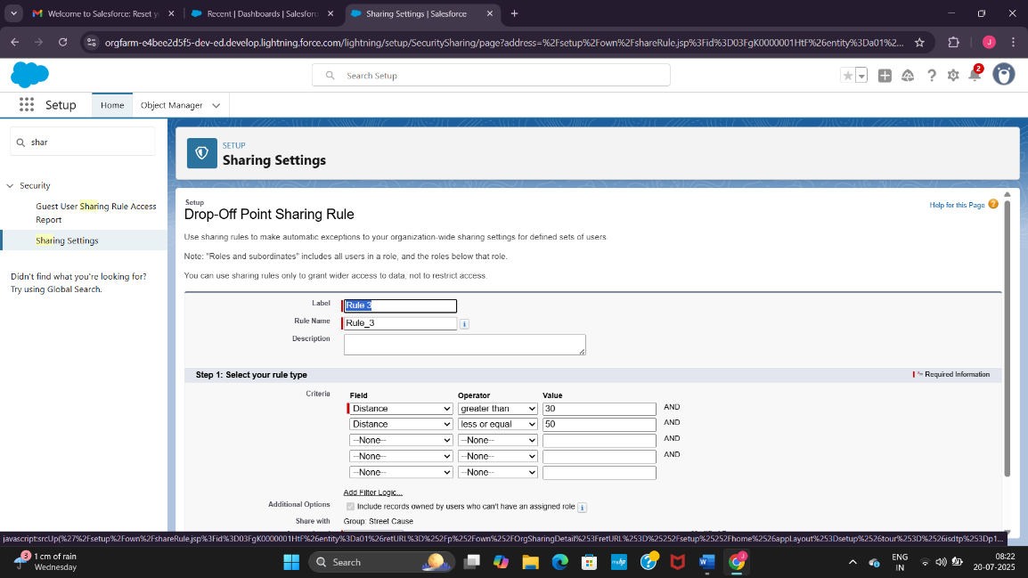

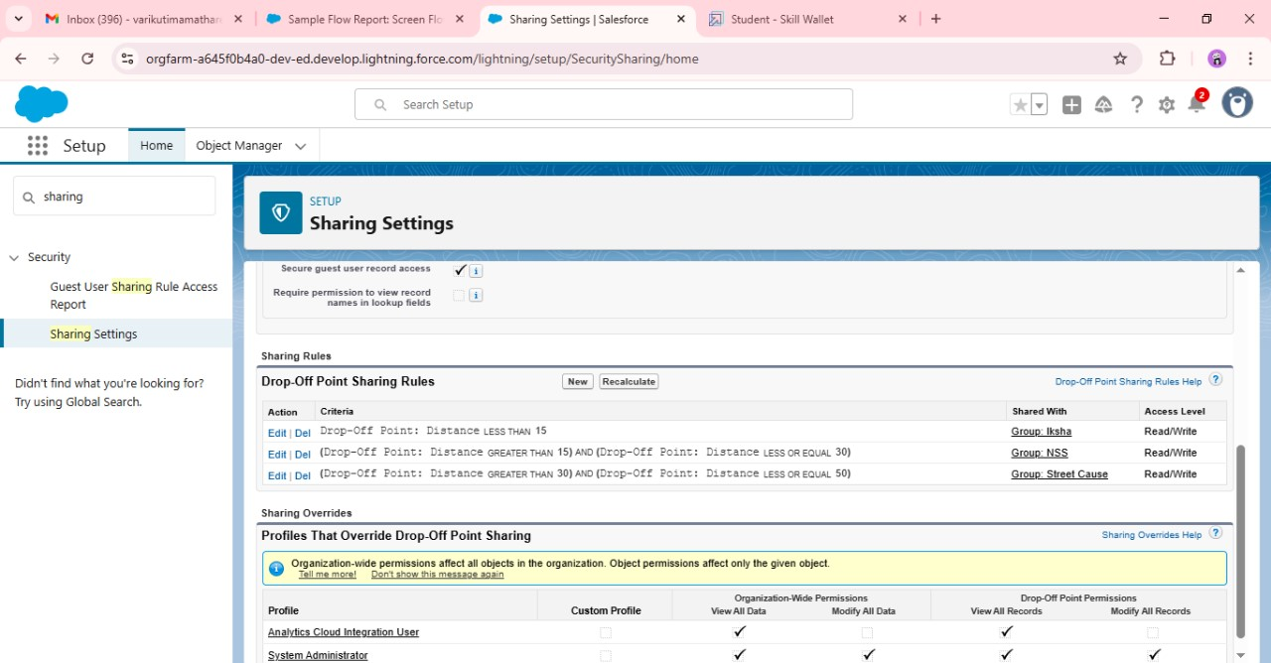

**PHASE – 5 :Deployment , Documentation & Maintenance :**

This is the last step or the last phase of the project.

In this phase we generate the home page by adding our app the Food Connect to the app defaulter that generates the home page of the app.

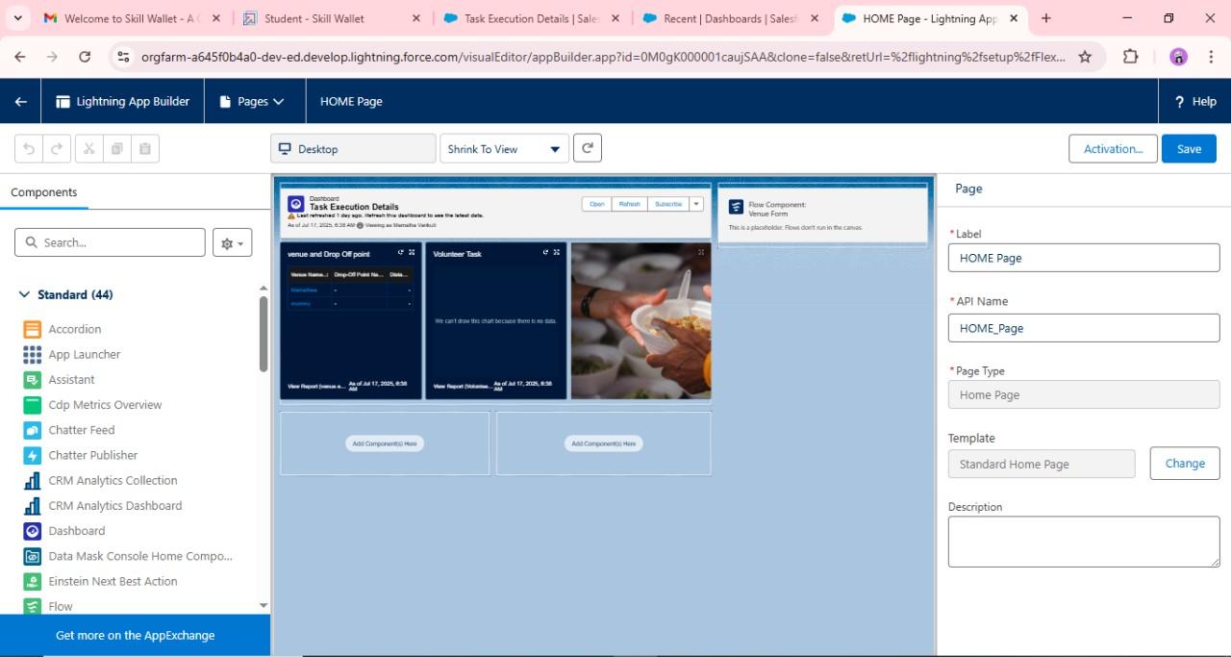

After connecting the Food Connect app to app defaulter the home page will be generated and it will look like this.

We can in addition also add a few pictures related to the work we do and with that we can update it day to day by adding more information like our day to day work pictures details of what we do with that we can also add the donor names if they are willing.

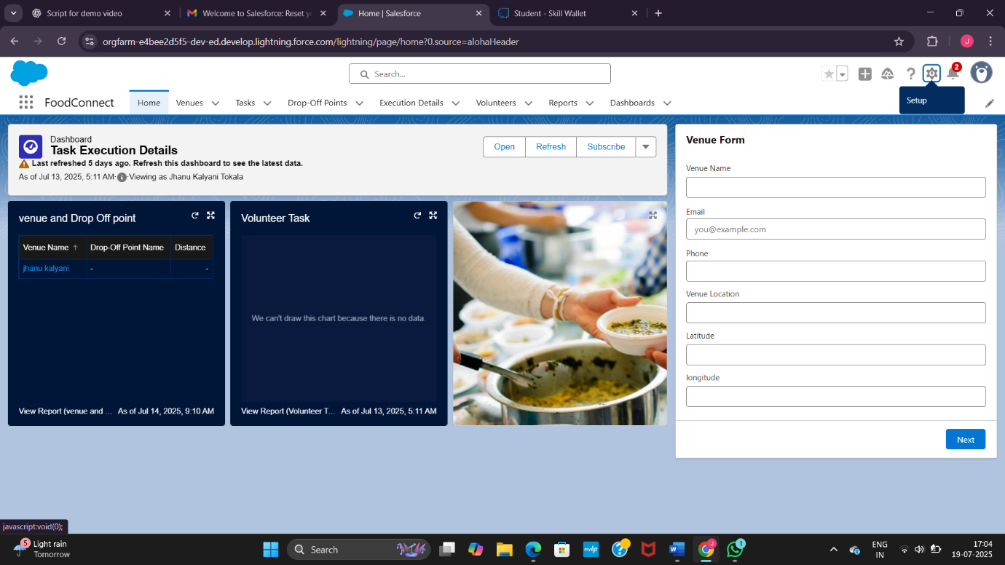

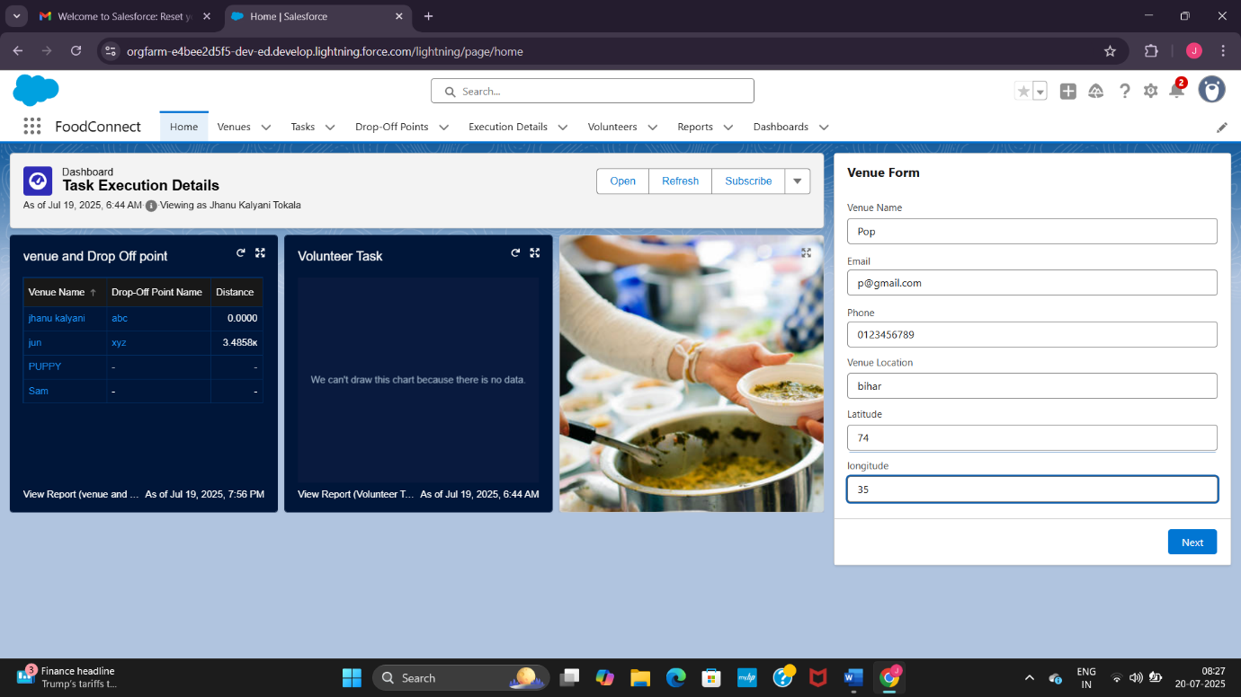

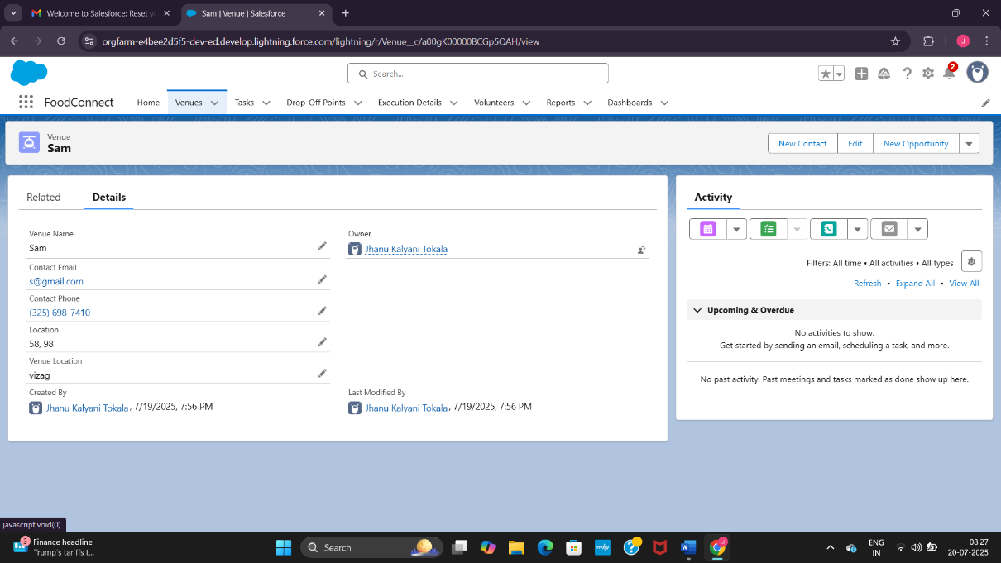

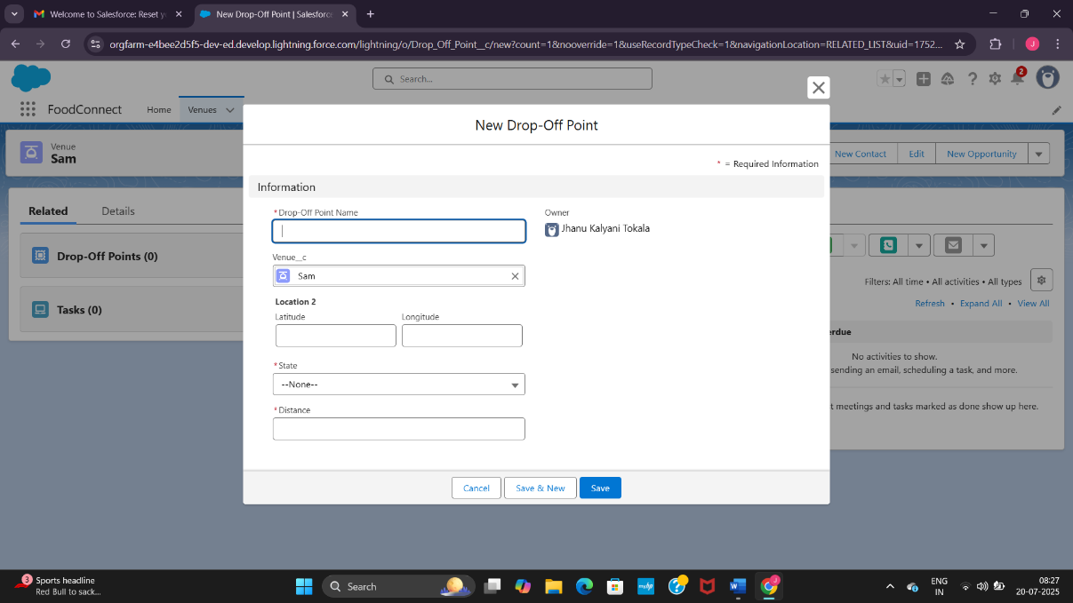

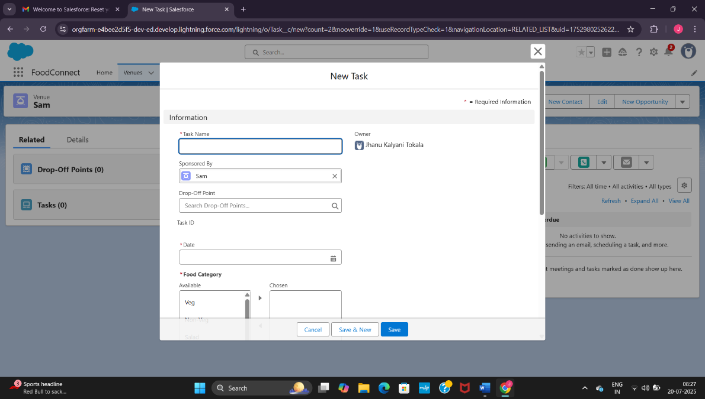

**CONCLUSION :**

The salesforce Food Connect App successfully enhances food distribution efficiency by leveraging Salesforce’s capabilities. It improves coordination and transparency in food donation efforts, addressing food insecurity and maximizing resource utilization.

A brief summary of what the project achieved:

* **Outcome:** A functional Salesforce application that enhances food distribution efficiency.
* **Impact:** Improved coordination and transparency in food donation efforts.

ADDITIONAL DETAILS :

In the additional details I would like to add my idea of including Artificial Intelligence(AI) into the app.

This AI would help us in many ways :

* Firstly it would help the unsophisticated users or naïve users to go through the app and get to know about it.
* It can also help the people who do not know how to become a volunteer and how to donate food through voice assistant.
* It can give faster and more accurate directions to the location volunteers need to reach.
* Lastly it can also protect the security and detect any fraud access into the app.